# SALES DATA ANALYSIS

**A Project Report**

Submitted in partial fulfilment of the

Requirements for the award of the Degree of

**BACHELOR OF TECHNOLOGY**

**IN**

**DEPARTMENT OF COMPUTER SCIENCE AND ENGINEERING**

by

**N. RAJA JAGADEESH CHANDRA BOSE (1810164)**

**G. JAGADEESH (1810117)**

**K. MANASA (1810119)**

**Under the esteemed guidance of**

## SMT D. GOUSIYA BEGUM, M.Tech., (Ph.D.)

**Lecturer in Department of CSE**



**DEPARTMENT OF COMPUTER SCIENCE AND ENGINEERING**

**SRI KRISHNADEVARAYA UNIVERSITY**

**COLLEGE OF ENGINEERING AND TECHNOLOGY**

**ANANTAPUR – 515003 ANDHRA PRADESH**

**2018-2022**

**SRI KRISHNADEVARAYA UNIVERSITY**

**COLLEGE OF ENGINEERING AND TECHNOLOGY**

**ANANTAPUR – 515003**

**DEPARTMENT OF COMPUTER SCIENCE AND ENGINEERING**



**CERTIFICATE**

Certified that this is a bonafide record of the dissertation work entitled, **“SALES DATA ANALYSIS”,** done by **N. Raja jagadeesh chandra bose (1810164), G. Jagadeesh (1810117), K. Manasa (1810119)** submitted to the faculty of Computer Science and Engineering,in partial fulfilmentof therequirements for the Degree of **BACHELOR OF TECHNOLOGY** with specialization in **COMPUTER SCIENCE AND ENGINEERING** from Sri Krishnadevaraya University College of Engineering and Technology, Anantapur.

Signature of the Supervisor Signature of the Head of the Department(I/C)

**SMT D. GOUSIYA BEGUM M.Tech (Ph.D.)** **Mr.** **P.R. RAJESH KUMAR****M.Tech (Ph.D.)**

**DEPARTMENT OF CSE DEPARTMENT OF CSE**

**DECLARATION**

We hereby declare that the project report entitled **“SALES DATA ANALYSIS”** submitted to the Department of Computer Science and Engineering, Sri Krishnadevaraya University, Anantapur for the partial fulfilment of the academic requirement for the degree for Bachelor of Technology in Computer Science and Engineering is an authentic record of our work carried out during the final year under the esteemed guidance of **SMT. D. GOUSIYA BEGUM M.Tech(Ph.D.)**, Lecturer Computer Science and Engineering Department, College of Engineering and Technology, Sri Krishnadevaraya University, Anantapur.

Signature of the students

1. N. Raja jagadeesh chandra bose

2. G. Jagadeesh

3. K. Manasa

**ACKNOWLEDGEMENT**

The satisfaction and euphoria that accompany the successful completion of any task would be incomplete without the mention of people who made it possible whose constant guidance and encouragement crowned our efforts with success. It is a pleasant aspect that I have now the opportunity to express my gratitude for all of them

It is with immense pleasure that I would like to express my indebted gratitude **to** my **SMT. D. GOUSIYA BEGUM M.Tech (Ph.D.)** in **CSE Department**, who has guided me a lot and encouraged me in every step of the project work. His valuable moral support and guidance throughout the project helped me to a greater extent. I thank him for his stimulating guidance, constant encouragement and constructive criticism which have made possible to bring out this project work.

I wish to express my deep sense of gratitude to **Mr.** **P.R. RAJESH KUMAR, M.Tech (Ph.D.),** Lecturer and **Head of the Department (I/C) of Computer Science and Engineering,** for giving me the opportunity of doing the project and for providing a great support in completing my project work. I feel elated to thank him for inspiring me all the way by providing good lab facilities and helping me in providing such good environment.

I wish to convey my acknowledgment to **Dr. R. RAMACHANDRA, M.Tech., Ph.D.,** Principal, **SKU College of Engineering and Technology, Anantapur**, for providing such a good environment and facilities.

My special thanks to the faculty of CSE Department for giving the required information in doing my project work. Not to forget, I thank all the non-teaching staff, my friends and class mates who had directly or indirectly helped and supported me in completing my project in time.

Finally, I wish to convey my gratitude to my parents who fostered all the requirements and facilities that I need.

**N. RAJA JAGADEESH CHANDRA BOSE - 1810164**

**G. JAGADEESH - 1810117 . K. MANASA - 1810119**

**ABSTRACT**

Data is recognized as a basic form of information that needs collection, management, mining and interpretation to create knowledge. The advantages of the collection of digitalized data and build data banks has brought in great challenges of data processing for better and meaningful results according to mass data deposits. Clustering techniques therefore are necessary in sales data analysis which can have access to process data in decision making processes. This is actually defined as the sales forecasting. A sales forecast is an expression of expected sales revenue. A sales forecast estimates how much your company plans to sell within a certain time period (like quarter or year). The best sales forecasts do this with a high degree of accuracy.

  Finding trends within sales and discovering the most important factors affecting sales are interesting issues. A lot of methods are created to analyse sales. Furthermore, transactional data are stored in databases. This data is used by many managers to make different types of analysis, e.g., ABC, XYZ, what-if analysis, top 10 customers and top 10 items.

The purpose of sales analysis using Data Analytics is to present some basic ideas on sales analysis that support the process of determining the minimum stock and profit margin by grouping items into categories “Fast moving” and “slow moving” and “Dead Stock” of the sale using Data analysis tools. The main aim of the sales analysis to reason and illustrate the rectangle method for sales analysis. The illustration is done with a sample dataset. The core of the rectangle method is to find product items that may be offered to shops which have not ordered them. The practical implications of this paper concern other practitioners. They may use the rectangle method as an additional one to other frequently used sales analysis methods.

**TABLE OF CONTENTS** Page No:

**ACKNOWLEDGEMENT** 4

**ABSTRACT** 5

**LIST OF FIGURES**  8

### CHAPTER 1: INTRODUCTION 9

1.1. Introduction 9-13

1.2. Literature Survey 12

1.3. Problem Formulation 13

1.4. Objective 14-15

### CHAPTER 2: SYSTEM REQIREMENTS AND SPECIFICATIONS 16

2.1 Introduction 16

2.2 Hardware Requirements 16

2.3 Software Requirements 16-17

2.4Software Requirements Specifications18

### CHAPTER 3: SYSTEM ANALYSIS 19

3.1 Introduction 19

3.2 Problem Analysis 19

3.3 Feasibility Solution 20

### CHAPTER 4: SYSTEM DESIGN SPECIFICATION 21

4.1Data Analysis 21-25

4.2 Data Servers or sources 26-39

4.3 Data Warehousing (ETL) 39-49

4.4 Model Planning and Model Building 49-51

### CHAPTER 5: SYSTEM IMPLEMENTATION 52

**5.1 Sales** Analysis Implementation 52-57

**CHAPTER 6: RESULTS AND DISCUSSIONS** 57

6.1 Reports Creation 58-60

6.2 Decision making 60-61

6.3 Limitations 62

6.4 Future Scope 62

**CHAPTER 7: SCREENSHOTS**  63-64

### CHAPTER 8: CONCLUSION AND FUTURE WORK 65

8.1 Conclusion 65

8.2 FutureWork 65

**CHAPTER 9: REFERENCES** 66

### LIST OF FIGURES

1.2.1: Business analysis dashboard 9

1.2.2: Sales KPI Dashboard 10

1.2.3: Sales Cycle length Dashboard 11

1.2.4: Sales Conversion Dashboard 12

2.4.1: Power BI Service 16

## 2.4.2 Fig: On-premises reporting with Power BI Report Server 17

4.1.1 Concept of Bug data processing and storage: cloud to database 21

4.1: Data Analysis Life Cycle 22

4. 2: Power Bi Data Sources 25-37

4.3 Data Transformation 38-48

4.4 Model Building 50

5.1 Sales Data Analysis 52-56

6.1 Reports creation of sales Data 57-59

7 Screenshots 61-62

### CHAPTER 1

### INTRODUCTION

#### 1.1 INTRODUCTION

A sales analysis is a detailed report that shows a business's sales performance, as well as customer data and generated revenue. The report defines the strengths and weaknesses of products and sales teams by referencing historical and current metrics to detect emerging trends that are most relevant to a company.

Sales Analysis I mining the data to evaluate the performance of your sales team against its goals. It provides insights about the top performing and underperforming Products/Services, the problems in selling and market opportunities, sales forecasting, and sales activities that generate revenue. Regular sales data analysis provides an understanding of the products that your customers are buying and helps to dissect why they are behaving in a certain way. You can also find patterns in your lead conversions and drop offs. All of these aspects enable us to optimize your sales process.

Sales analysis examines sales reports to see what goods and services have and have not sold well, and gives insights into why, explains [Forecasting](https://zipforecasting.com/en/cash-flow-projection/sales-analysis.html#:~:text=A%20sales%20analysis%20is%20a,most%20relevant%20to%20a%20company.). The analysis is used to determine how to stock inventory, how to measure the effectiveness of a sales force, how to set manufacturing capacity and to see how the company is performing against its goals. However, the prospect of sifting through the many sales metrics available to make sense of the data can be overwhelming, while knowing what to do with that information once you’ve got it is another challenge.

In some industries, sales made by your competitors are listed in public sources. For example, automobile sales are reported monthly by major manufacturer, major brand and model. This sales data is informative for all manufacturers, showing how well each competes against the rest. For example, data are routinely examined to see which automobile company sold the most midsized sedans, SUVs and trucks. Sales analysis provides critical values from which analysts can form actionable insights. This enables management to make data-driven decisions rather than relying on guesswork. Companies can discover where their most-profitable customers lie, where additional promotions needed, and which products need quicker turnover.

#### 1.1.2 OVERVIEW

Our Project proposes a technique that a business organizational data can be analysed using data analysis techniques where we can find most important metrics that can turn a business organisation leading their future with more profitable ways.

**1.2 LITERATURE SURVEY**

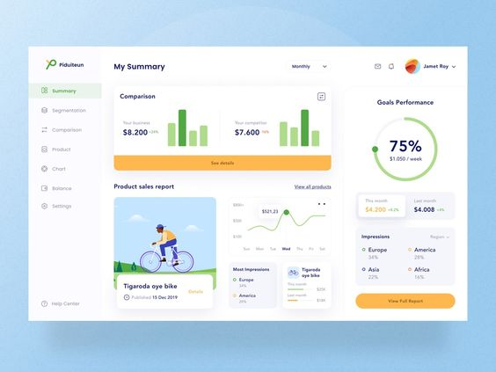

**Fig1.2.1: Business Analysis Dashboard**

A business intelligence dashboard, or BI dashboard, is a [data visualization](https://www.techtarget.com/searchbusinessanalytics/definition/data-visualization) and analysis tool that displays on one screen the status of key performance indicators (KPIs) and other important business metrics and data points for an organization, department, team or process. Dashboards are an integral component of most [BI](https://www.techtarget.com/searchbusinessanalytics/definition/business-intelligence-BI) software platforms and are widely used to deliver analytics information to business executives and workers.

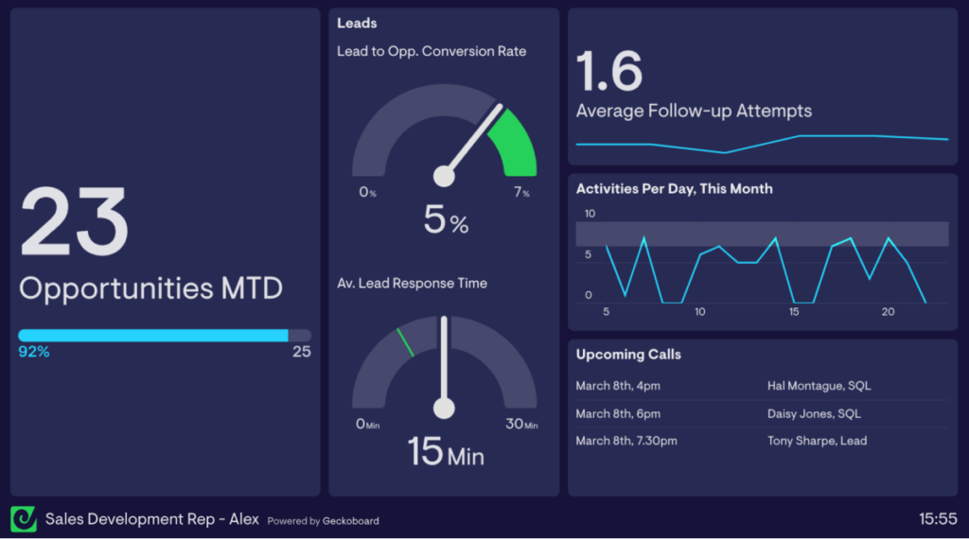

**Fig1.2.2: Sales KPI Dashboard**

**KPIs used**: Opportunities created against target, lead response time, average follow-up attempts.

The individual sales KPI dashboard is the **SDR’s accountability buddy**.

It keeps them on track with their sales activities and identifies potential blind spots.

For example, a low average follow-up attempts indicates that the SDR needs to set up a consistent follow-up routine.

Sales managers can **use this dashboard during sales training** and team meetings to share feedback, coach, and discuss areas for improvement.

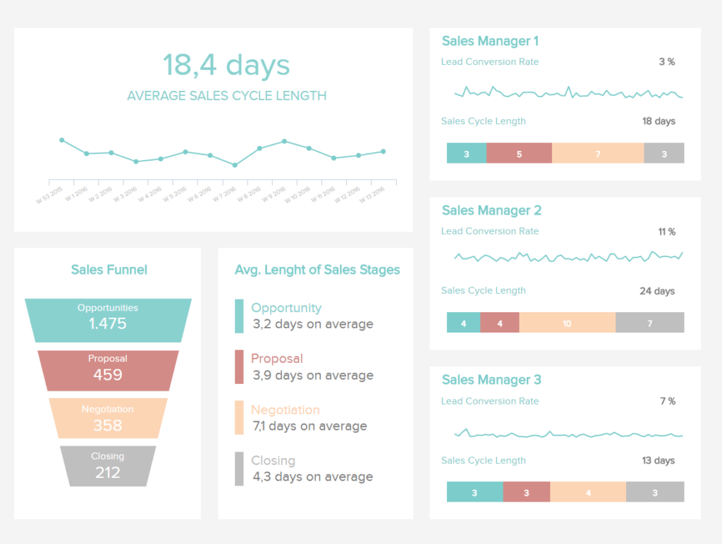

Fig: 1.2.3 Sales Cycle length Dash board

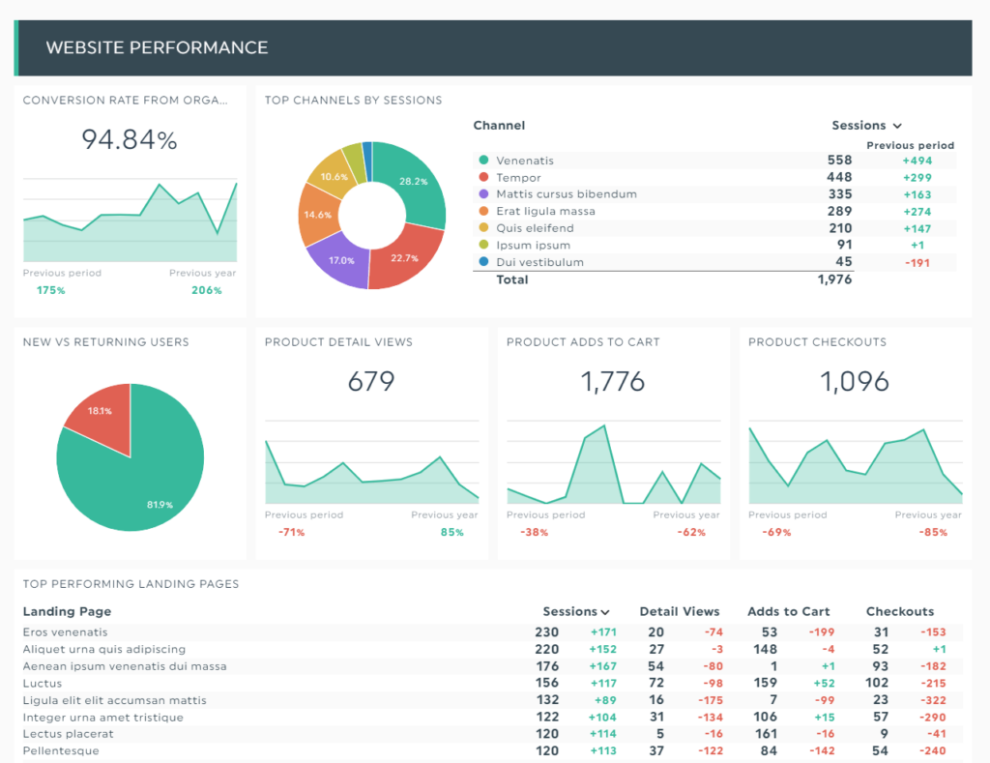

Fig: 1.2.4 Sales Conversion Dashboard

##### 1.3 PROBLEM FARMULATION

Case studies examine a single, salient business situation or organization by collecting key facts and analysing them in light of business functions, theories, and best practices. The goal is to generate possible solutions to problems experienced in that particular situation or organization. The case study begins with an explicit problem statement. Based on the problem statement, researchers decide what data need to be collected for analysis. For example, a company case study usually needs to collect both quantitative (e.g., financial and sales figures) and qualitative (e.g., management memos and reports) data to perform the following analyses

###### 1.3.1 EXISTING SYSTEM

A sales trend analysis focuses on finding patterns from sales data within a specific timeframe. Many retailers use this method to determine micro and macro trends. A micro-trend covers a particular line of product for a week or so, while a macro trend may track a range of goods over method enables management to determine their progress towards sales goals and detect increasing or decreasing product demand.

A performance analysis measures the effectiveness of a sales strategy by monitoring a sales team's performance. Aside from tracking sales per rep and other KPIs, this method often requires a financial analysis based on revenue generated from a certain department or period.  
  
 Analysts can also tailor the report to cover win rates, revenue growth, profit margins, and any other area of interest. This tactic shows sales teams their current performance levels and how it compares to what is expected.

###### 1.3.2 PROPOSED SYSTEM

We have implemented a data analytics technique that performs on the raw data where it is being collected and the data is very large in size. Though instead of every time collecting the data manually will be little bit hard to perform the same task, we have implemented this technique in Power BI and we have set the data access from different sources will be set to automatic and will be updated as soon as the data collected to a data source or may be updated. And the Application that we have used

**1.4 OBJECTIVE**

Sales objectives give your sales team members a clear roadmap of what they need to do to help your company achieve its overall goals. Each objective comprises specific, measurable action items that help salespeople make sure individual and team-wide goals are achieved.

Sales objectives are broad strokes of the brush, like increasing customer numbers, hitting revenue targets or cutting churn rates. They are usually long-term benchmark goals, made up of shorter-term steps.

The sales objectives you set need to make sense for your business or department. You might be setting sales objectives that focus on:

Increasing annual sales and profit

Increasing customer numbers

Increasing upsells and cross-sells

Improving customer retention

Increasing conversion rates

Increasing sales rep productivity

Cutting the time sales reps spend on non-sales tasks

Enhancing your sales processes and sales activities

Increasing outreach to qualified leads and cutting time wasted on unqualified leads

Remember, there’s a difference between setting sales objectives and setting sales objectives that work. Just because you plan something doesn’t mean it will get done.

This is why any sales target that has a chance of succeeding needs to be set in steps. In other words, you should consider executing goal setting using a SMART goals mindset.

Specific: A clear explanation of the objective and its steps

Measurable: Ensure there are metrics that you can measure to analyze the objective’s success

Achievable: The objective should be realistic, but still challenging

Relevant: Make sure that the objectives are consistent with your business goals, team goals and individual goals

Time-based: Set out an accurate and clear timescale for the objective

**CHAPTER 2**

**SYSTEM REQUIREMENTS AND SPECIFICATIONS**

#### 2.1 INTRODUCTION

A **System Requirements Specification (SRS)** (also known as a Software Requirements Specification) is a document or set of documentation that describes the features and behaviour of a system or software application. It includes a variety of elements (see below) that attempts to define the intended functionality required by the customer to satisfy their different users.

In addition to specifying how the system should behave, the specification also defines at a high-level the main business process that will be supported, what simplifying assumptions have been made and what **key performance parameters** will need to be met by the system.

#### 2.2 HARDWARE REQUIREMENTS

* Processor: I5 or above 8th gen
* Ram: 4gb
* GPU: Gt 1030 ti
* Hard Disk: 10gb

#### 2.3 Software Requirements

POWER BI – This is a Business Intelligence Tool

MySQL – Data source that is used in this project

SQL – Programming Language for Querying the Data in a Relational Database

DAX – Data Analysis Expressions is a language that is used for evaluation of data for data Transformation in the Data processing tools such as POWER BI, EXCEL.

#### 2.4 Software Requirements Specifications

**Introduction to Power BI:**

Power bi is collection of software services, apps and connections that work together to turn your unrelated sources of data into coherent, visually immersive, and interactive insights. Your data may be an Excel spreadsheet or a collection of cloud based and on-premises hybrid data warehouses.

## The parts of Power BI

Power BI consists of several elements that all work together, starting with these three basics:

* A Windows desktop application called **Power BI Desktop**.
* An online SaaS *(*Software as a Service) service called the **Power BI service**.
* Power BI **mobile apps** for Windows, iOS, and Android devices.

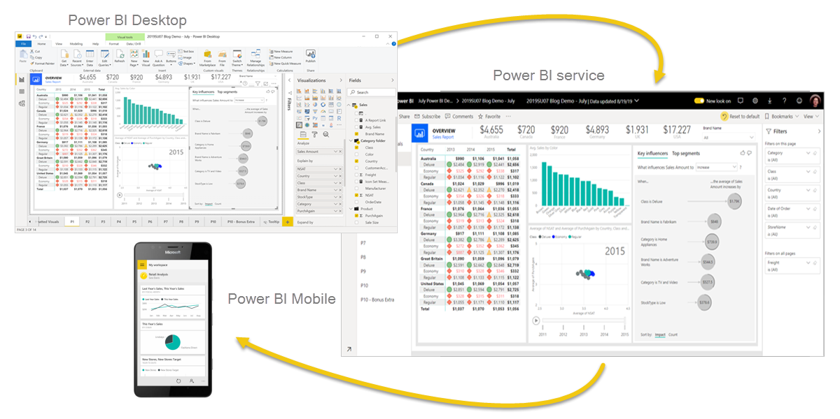

**Fig 2.4.1: Power BI Service**

One common workflow in Power BI begins by connecting to data sources in Power BI Desktop and building a report. You then publish that report from Power BI Desktop to the Power BI service, and share it so business users in the Power BI service and on mobile devices can view and interact with the report.

This workflow is common, and shows how the three main Power BI elements complement one another.

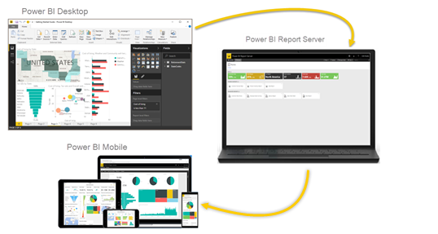

## 2.4.2 Fig: On-premises reporting with Power BI Report Server

Power BI Report Server is a solution that you deploy behind your firewall and then deliver your reports to the right users in different ways, whether that's viewing them in a web browser, on a mobile device, or as an email. And because Power BI Report Server is compatible with Power BI in the cloud, you can move to the cloud when you're ready.

#### CHAPTER 3

#### SYSTEM ANALYSIS

**3.1 INTRODUCTION:**

System Analysis is a process of collecting factual data, understand the processes involved, identifying problems and recommending feasible suggestions for improving the system functioning. This involves studying the business processes, gathering operational data, understand the information flow, finding out bottlenecks and evolving solutions for overcoming the weakness of the system so as to achieve the organizational goals. System Analysis also includes subdividing of complex process involving the entire system, identification of data store and manual processes.

The major objectives of system analysis are to find answers for each business process, what is being done, how is it being done, who is doing it, when is he doing it, why is it being done and how is it being done, who is doing it, when is he doing it, why is it being done and how can it be improved? It attempts to give birth to a new efficient system that satisfies the current needs of the user and has scope for future growth within the organizational constraints. The result of this process is logical system design. System analysis is an iterative process that continues until a preferred and acceptable solution emerges.

**3.2 PROBLEM ANALYSIS:**

A sales analysis is a report that provides a deep glimpse into the performance of your sales team, including their successes and their shortcomings, as well as customer shopping data and incoming revenue. In your report, you want to see such information as current and past sales and emerging trends that matter most to your business.

By collecting and cross-referencing in sales data analysis, it’s possible to build highly-personalized value propositions tailored to the specific needs of each customer segment. Another challenge is setting the price of new products and services to ensure maximum sales and revenue.

1. **Determines the present position:**

The main objective of our project is to fulfil the organisational requirements for satisfying them with the best business strategy.

1. **Understanding client’s requirements:**

Provides required solutions for the business problems, which helps them to increase product sales and satisfying them with business improvement strategies and providing the reports as well make it easier to understand what is happened in the past few years.

**3.3 FEASIBILITY STUDY:**

In case the system proposal is acceptable to the management, the next phase is to examine the feasibility of the system. The feasibility study is basically the test of the proposed system in the light of its workability, meeting user’s requirements, effective use of resources. These are categorized as technical, operational, economical and schedule feasibility. The main goal of feasibility study is not to solve the problem but to achieve the scope. The result is a feasibility report submitted to the management. This may be accepted or rejected. The system cycle proceeds only if the management accepts it.

**CHAPTER 4**

#### SYSTEM DESIGN SPECIFICATIONS

##### 4.1 INTRODUCTION

The world is becoming more and more data-driven, with endless amounts of data available to work with. Big companies like Google and Microsoft use data to make decisions, but they're not the only ones.

Data analysis is used by small businesses, retail companies, in medicine, and even in the world of sports. It's a universal language and more important than ever before. It seems like an advanced concept but data analysis is really just a few ideas put into practice

##### 4.2 Data Analysis

Data analysis is the process of evaluating data using analytical or statistical tools to discover useful information. Some of these tools are programming languages like R or Python. [Microsoft Excel is also popular in the world of data analytics](https://www.makeuseof.com/tag/data-analysis-excel/).

Once data is collected and sorted using these tools, the results are interpreted to make decisions. The end results can be delivered as a summary, or as a visual like a chart or graph.

The process of presenting data in visual form is known as **data visualization**. Data visualization tools make the job easier. Programs like Tableau or Microsoft Power BI give you many visuals that can bring data to life.

There are several data analysis methods including data mining, text analytics, and business intelligence.

* Defining objectives
* Posing Questions
* Data Collection
* Data Scrubbing
* Data Analysis
* Drawing conclusions and making predictions

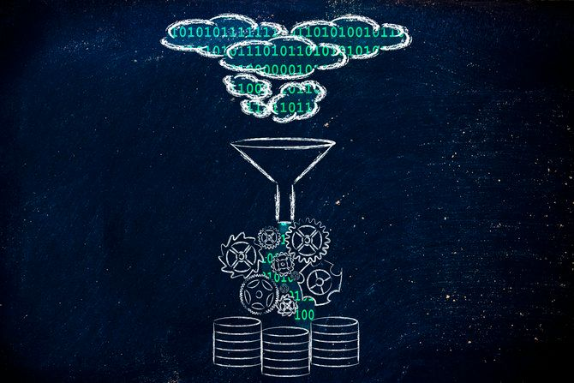

**Fig: 4.1.1 Concept of Bug data processing and storage: cloud to database**

**Data analysis is a big subject and can include some of these steps:**

* **Defining Objectives:** Start by outlining some clearly defined objectives. To get the best results out of the data, the objectives should be crystal clear.
* **Posing Questions:** Figure out the questions you would like answered by the data. For example, do red sports cars get into accidents more often than others? Figure out which data analysis tools will get the best result for your question.
* **Data Collection:** Collect data that is useful to answer the questions. In this example, data might be collected from a variety of sources like DMV or police accident reports, insurance claims and hospitalization details.
* **Data Scrubbing:** Raw data may be collected in several different formats, with lots of junk values and clutter. The data is cleaned and converted so that data analysis tools can import it. It's not a glamorous step but it's very important.
* **Data Analysis:** Import this new clean data into the data analysis tools. These tools allow you to explore the data, find patterns, and answer what-if questions. This is the payoff; this is where you find results!
* **Drawing Conclusions and Making Predictions:** Draw conclusions from your data. These conclusions may be summarized in a report, visual, or both to get the right results.

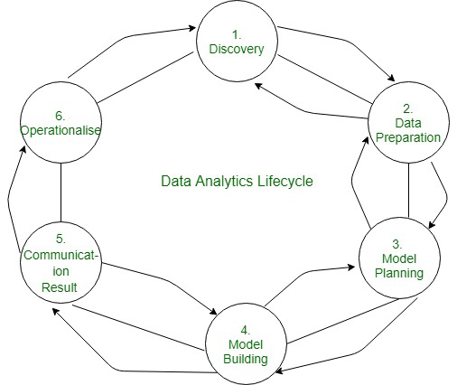

###### Figure 4.1: Data Analysis Life Cycle

we are going to discuss life cycle phases of data analytics in which we will cover various life cycle phases and will discuss them one by one.

**DATA ANALYTICS LIFE CYCLE:**

The [Data analytic](https://www.geeksforgeeks.org/data-analytics-and-its-type/) lifecycle is designed for Big Data problems and data science projects. The cycle is iterative to represent real project. To address the distinct requirements for performing analysis on Big Data, step – by – step methodology is needed to organize the activities and tasks involved with acquiring, processing, analysing, and repurposing data.

**Phase 1: Discovery –**

* The data science team learn and investigate the problem.
* Develop context and understanding.
* Come to know about data sources needed and available for the project.
* The team formulates initial hypothesis that can be later tested with data.

**Phase 2: Data Preparation –**

* Steps to explore, pre-process, and condition data prior to modelling and analysis.
* It requires the presence of an analytic sandbox, the team execute, load, and transform, to get data into the sandbox.
* Data preparation tasks are likely to be performed multiple times and not in predefined order.
* Several tools commonly used for this phase are – Hadoop, Alpine Miner, Open Refine, etc.

**Phase 3: Model Planning –**

* Team explores data to learn about relationships between variables and subsequently, selects key variables and the most suitable models.
* In this phase, data science team develop data sets for training, testing, and production purposes.
* Team builds and executes models based on the work done in the model planning phase.
* Several tools commonly used for this phase are – Matlab, STASTICA.

**Phase 4: Model Building –**

* Team develops datasets for testing, training, and production purposes.
* Team also considers whether its existing tools will suffice for running the models or if they need more robust environment for executing models.
* Free or open-source tools – Rand PL/R, Octave, WEKA.
* Commercial tools – MATLAB, STASTICA.

**Phase 5: Communication Results –**

* After executing model team need to compare outcomes of modelling to criteria established for success and failure.
* Team considers how best to articulate findings and outcomes to various team members and stakeholders, taking into account warning, assumptions.
* Team should identify key findings, quantify business value, and develop narrative to summarize and convey findings to stakeholders.

**Phase 6: Operationalize –**

* The team communicates benefits of project more broadly and sets up pilot project to deploy work in controlled way before broadening the work to full enterprise of users.
* This approach enables team to learn about performance and related constraints of the model in production environment on small scale, and make adjustments before full deployment.
* The team delivers final reports, briefings, codes.
* Free or open-source tools – Octave, WEKA, SQL, MADlib.

**Data Mining:**

mining is a method of data analysis for discovering patterns in large data sets using statistics, artificial intelligence, and machine learning. The goal is to turn data into business decisions.

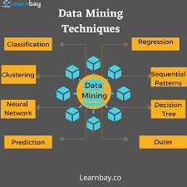

**Fig: Data Mining Example Image**

What can you do with data mining? You can process large amounts of data to identify outliers and exclude them from decision making. Businesses can learn customer purchasing habits, or use clustering to find previously unknown groups within the data.

If you use email, you see another example of data mining to sort your mailbox. Email apps like Outlook or Gmail use this to categorize your emails as "spam" or "not spam".

**Text Analytics:**

Data is not just limited to numbers; information can come from text information as well.

Text analytics is the process of finding useful information from text. You do this by processing raw text, making it readable by data analysis tools, and finding results and patterns. This is also known as text mining.

Excel does a great job with this. [Excel has many formulas to work with text that can save you time](https://www.makeuseof.com/tag/saving-time-text-operations-excel/) when you go to work with the data.

Text mining can also collect information from the web, a database or a file system. What can you do with this text information? You can import email addresses and phone numbers to find patterns. You can even find frequencies of words in a document.

**Business Intelligence:**

Business intelligence transforms data into intelligence used to make business decisions. It may be used in an organization's strategic and tactical decision making. It offers a way for companies to examine trends from collected data and get insights from it.

Business intelligence is used to do a lot of things:

* Make decisions about product placement and pricing
* Identify new markets for product
* Create budgets and forecasts that make more money
* Use visual tools such as heat maps, pivot tables, and geographical mapping to find the demand for a certain product

**Data Visualization:**



Data visualization is the visual representation of data. Instead of presenting data in tables or databases, you present it in charts and graphs. It makes complex data more understandable, not to mention easier to look at.

Increasing amounts of data are being generated by applications you use (Also known as the "Internet of Things"). [The amount of data (referred to as "big data")](https://www.makeuseof.com/tag/what-is-big-data/) is pretty massive. Data visualization can turn millions of data points into simple visuals that make it easy to understand.

There are various ways to visualize data:

* Using a data visualization tool like Tableau or Microsoft Power BI
* Standard Excel graphs and charts
* Interactive Excel graphs
* For the web, a tool like D3.js built using JavaScript

The [visualization of Google datasets](https://www.makeuseof.com/tag/google-dataset-search-results/) is a great example of how big data can visually guide decision-making.

##### 4.2 DATA SERVERS OR SOURCES

**Data Sources in POWER BI Desktop:**

You connect to data by using the home ribbon. To show the most common dta types menu, select the get data button label or the down arrow.

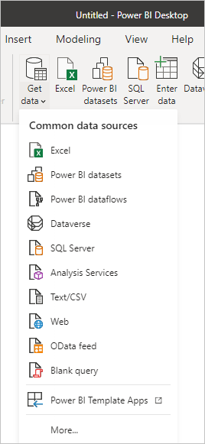

**Fig4.2.1: Power Bi Data Sources**

To go to the get Data dialog box, show the most common data types menu and select More. you can also bring up the get Data dialog box by selecting the get Data icon directly.

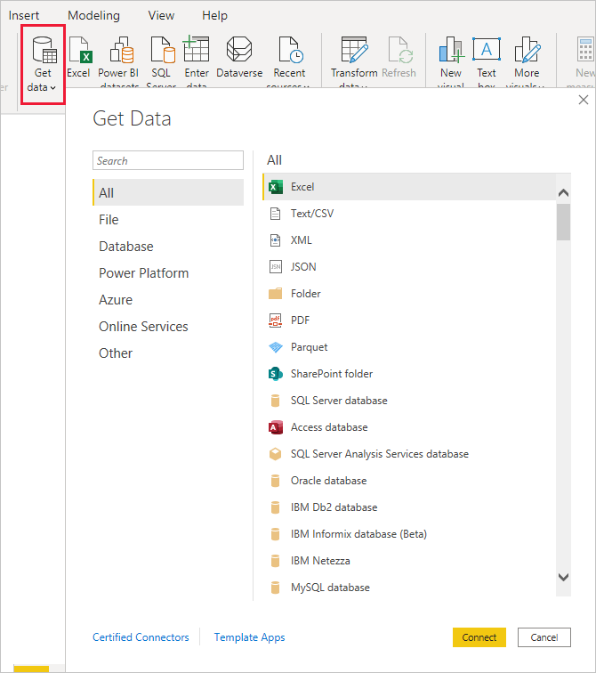

**Fig 4.2.2: Procedure for accessing Data Sources**

**Data sources:**

The Get Data dialog box organizes data types in the following categories:

All

File

Database

Power Platform

Azure

Online Services

Other

The All category includes all data connection types from all categories.

File data sources

The File category provides the following data connections:

* Excel Workbook
* Text/CSV
* XML
* JSON
* Folder
* PDF
* Parquet
* SharePoint folder

The following image shows the Get Data window for File.

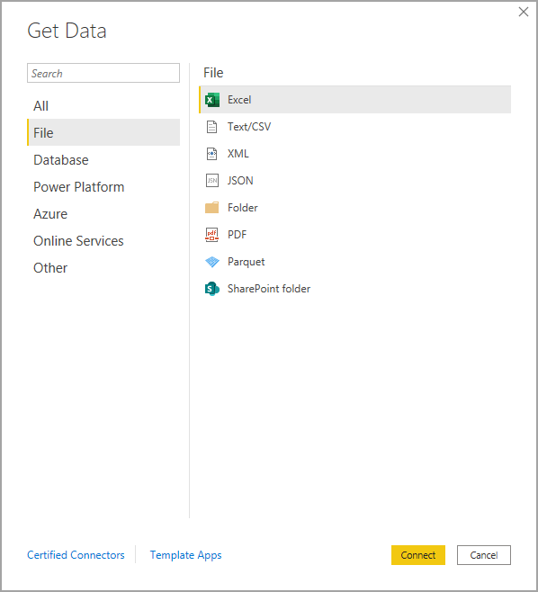

**Fig 4.2.3 File Data bases**

**Database data sources**

The Database category provides the following data connections:

* SQL Server database
* Access database
* SQL Server Analysis Services database
* Oracle database
* IBM Db2 database
* IBM Informix database (Beta)
* IBM Netezza
* MySQL database
* PostgreSQL database
* Sybase database
* Teradata database
* SAP HANA database
* SAP Business Warehouse Application Server
* SAP Business Warehouse Message Server
* Amazon Redshift
* Impala
* Google BigQuery
* Vertica
* Snowflake
* Essbase
* Actian (Beta)
* Amazon Athena
* BI Connector
* Data Virtuality LDW
* Denodo
* Dremio Software
* Dremio Cloud (Beta)
* Exasol
* Indexima
* InterSystems IRIS (Beta)
* Jethro (Beta)
* Kyligence
* Linkar PICK Style / MultiValue Databases (Beta)
* MariaDB
* MarkLogic
* TIBCO(R) Data Virtualization
* AtScale cubes

The following image shows the Get Data window for Database.

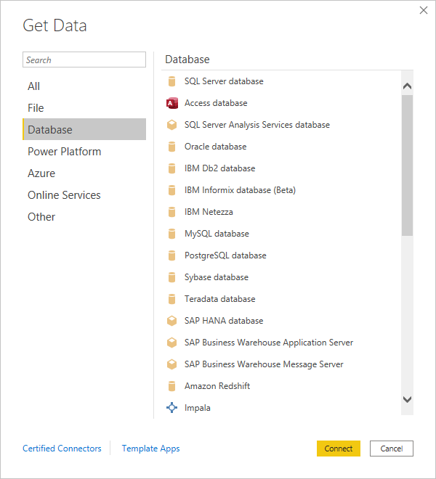

**Fig 4.2.4 Database Sources**

**Power Platform data sources**

The Power Platform category provides the following data connections:

* Power BI datasets
* Power BI dataflows
* Common Data Service (Legacy)
* Dataverse
* Dataflows
* The following image shows the Get Data window for Power Platform.

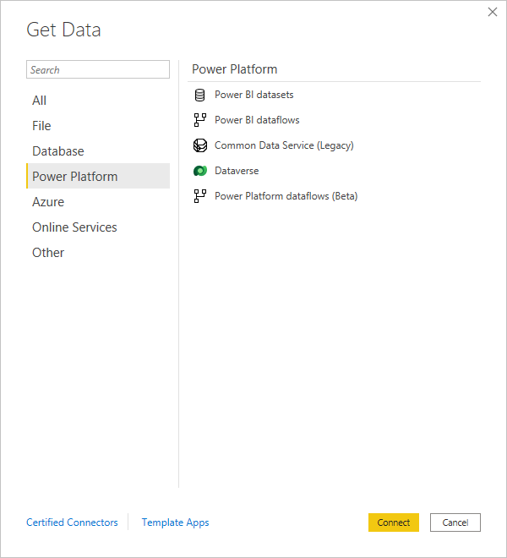

**Fig 4.2.5 Power Platform Data Sources**

**Azure data sources:**

The Azure category provides the following data connections:

* Azure SQL Database
* Azure Synapse Analytics SQL
* Azure Analysis Services database
* Azure Database for PostgreSQL
* Azure Blob Storage
* Azure Table Storage
* Azure Cosmos DB
* Azure Data Explorer (Kusto)
* Azure Data Lake Storage Gen2
* Azure Data Lake Storage Gen1
* Azure HDInsight (HDFS)
* Azure HDInsight Spark
* HDInsight Interactive Query
* Azure Synapse Analytics workspace (Beta)
* Azure Time Series Insights (Beta)
* Azure Cost Management
* Azure Databricks

The following image shows the Get Data window for Azure

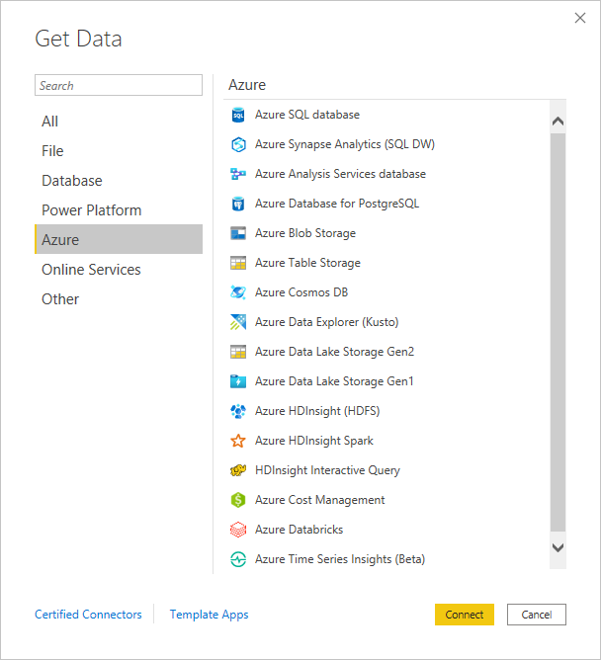

**Fig 4.2.6: Azure Data Sources**

**Online Services data sources:**

The Online Services category provides the following data connections:

* SharePoint Online List
* Microsoft Exchange Online
* Dynamics 365 (online)
* Dynamics 365 (Dataverse)
* Dynamics NAV
* Dynamics 365 Business Central
* Dynamics 365 Business Central (on-premises)
* Azure DevOps (Boards only)
* Azure DevOps Server (Boards only)
* Salesforce Objects
* Salesforce Reports
* Google Analytics
* Adobe Analytics
* appFigures (Beta)
* Data.World - Get Dataset (Beta)
* GitHub (Beta)
* LinkedIn Sales Navigator (Beta)
* Marketo (Beta)
* Mixpanel (Beta)
* Planview Enterprise One - PRM (Beta)
* QuickBooks Online (Beta)
* Smartsheet
* SparkPost (Beta)
* SweetIQ (Beta)
* Planview Enterprise One - CTM (Beta)
* Twilio (Beta)
* Zendesk (Beta)
* Asana (Beta)
* Assemble Views
* Automation Anywhere
* Automy Data Analytics (Beta)
* Dynamics 365 Customer Insights (Beta)
* Emigo Data Source
* Entersoft Business Suite (Beta)
* eWay-CRM
* FactSet Analytics
* Palantir Foundry
* Hexagon PPM Smart API
* Industrial App Store
* Intune Data Warehouse (Beta)
* Projectplace for Power BI
* Product Insights (beta)
* Quick Base
* SoftOne BI (beta)
* Spigit (Beta)
* TeamDesk (Beta)
* Webtrends Analytics (Beta)
* Witivio (Beta)
* Workplace Analytics (Beta)
* Zoho Creator (Beta)
* Digital Construction Works Insights (Beta)

The following image shows the Get Data window for Online Services.

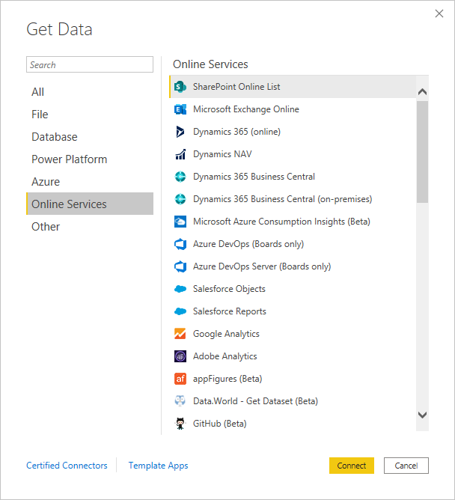

**Fig 4.2.6 Online Data Sources**

**Other data sources:**

The Other category provides the following data connections:

* Web
* SharePoint list
* OData Feed
* Active Directory
* Microsoft Exchange
* Hadoop File (HDFS)
* Spark
* Hive LLAP
* R script
* Python script
* ODBC
* OLE DB
* Acterys : Model Automation & Planning (Beta)
* Anaplan Connector v1.0 (Beta)
* Solver
* Bloomberg Data and Analytics
* Cherwell (Beta)
* Cognite Data Fusion
* Delta Sharing
* EQuIS (Beta)
* FHIR
* Google Sheets (Beta)
* Information Grid (Beta)
* Jamf Pro (Beta)
* Kognitwin
* MicroStrategy for Power BI
* Paxata
* QubolePresto (Beta)
* Roamler (Beta)
* SIS-CC SDMX (Beta)
* Shortcuts Business Insights (Beta)
* Siteimprove
* SumTotal
* SurveyMonkey (Beta)
* Microsoft Teams Personal Analytics (Beta)
* Tenforce (Smart)List
* Usercube (Beta)
* Vena
* Vessel Insight
* Zucchetti HR Infinity (Beta)
* BQE Core
* MicroStrategy for Power BI
* Starburst Enterprise
* Amazon OpenSearch Service (Beta)
* OpenSearch Project (Beta)
* Blank Query

The following image shows the Get Data window for Other.

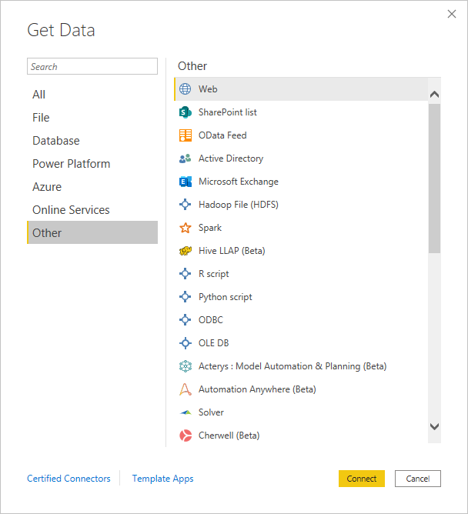

**Fig 4.2.7 Other Data Sources**

To load the data, select the Load button at the bottom of the Navigator pane. To transform or edit the query in Power Query Editor before loading the data, select the Transform Data button.

That’s all there is to connecting to data sources in Power BI Desktop! Try connecting to data from our growing list of data sources, and check back often - we continue to add to this list all the time.

##### 4.3 Data Warehousing

###### ETL (Extract, Transform, Load):

## Power BI Transform Data – Steps

The transformation steps can be performed in any order after importing data into Power Query Editor.

### Import Data

Today we will be working on data sourced from Excel. The first and foremost thing to do is import the data from the source to the Power BI. To import data, follow the step below:

1. Go to the “**Home”** tab in the ribbon section.
2. Click on “**Get Data**,” it will provide you with the options to source the data from a different platform.
3. As we have our unsorted data in Excel, Select **“Excel**.”

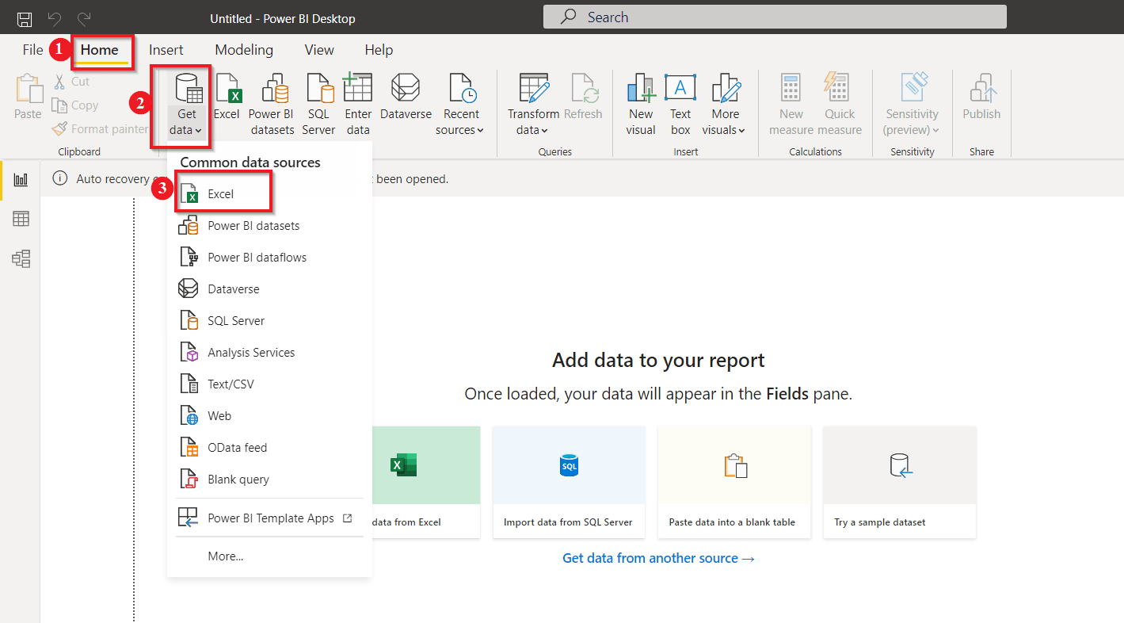

**Fig 4.3.1 Data Collection**

Then, it will open a window to select the “**Excel file”**that you want to upload from your computer.

Next, the “**Navigator”** page asks you to select the datasheets you want to work with; check to mark the sheets you wish to.

As we are intended to sort our data, we will go with the “**Transform Data**” option.

By clicking on Load, the file gets uploaded without any transformation.

###### Importing excel table

**Fig 4.3.1 Data Collection**

The Power BI transforms data button takes you to the other window, popularly known as **Power Query Editor,**where we will clean and transform our data.

To warm you up, let’s start with the easy one.

### Changing the Table Name

Let’s say we are not satisfied with table names, and to avoid confusion, we wish to change its name.

The table name can be changed from both the options shown in the picture below:

Just double-click the name you want to change and specify the new name, and there you go.

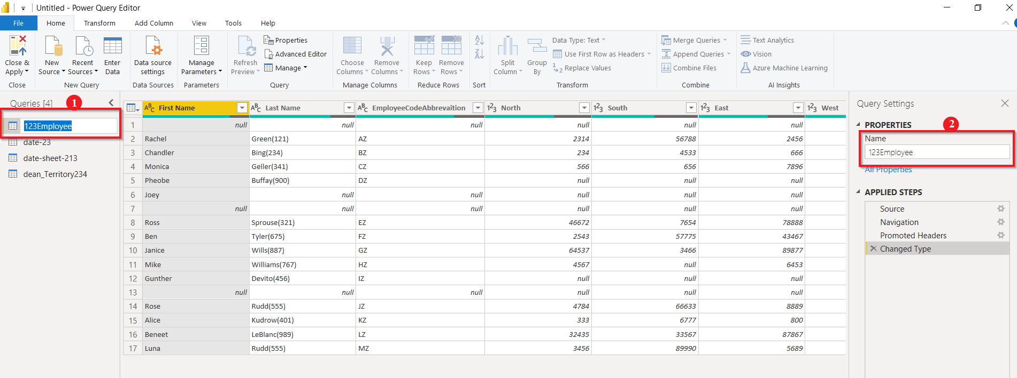

**Fig 4.3.2 Query management**

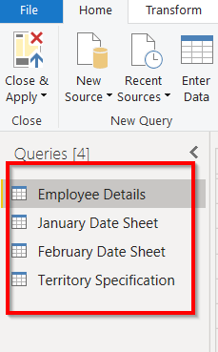

### Remove the First Row

Let’s move ahead and remove the first null row:

1. Go to the “**Home”** tab, select “**Remove Rows.”**
2. From the drop-down list, select “**Remove Top Rows**.”
3. Then, it will ask you to specify the number of rows you want to remove from the top.
4. Here we will remove the top row only; therefore, we specify 1, click on “**OK.”**

The final result is shown in the image.

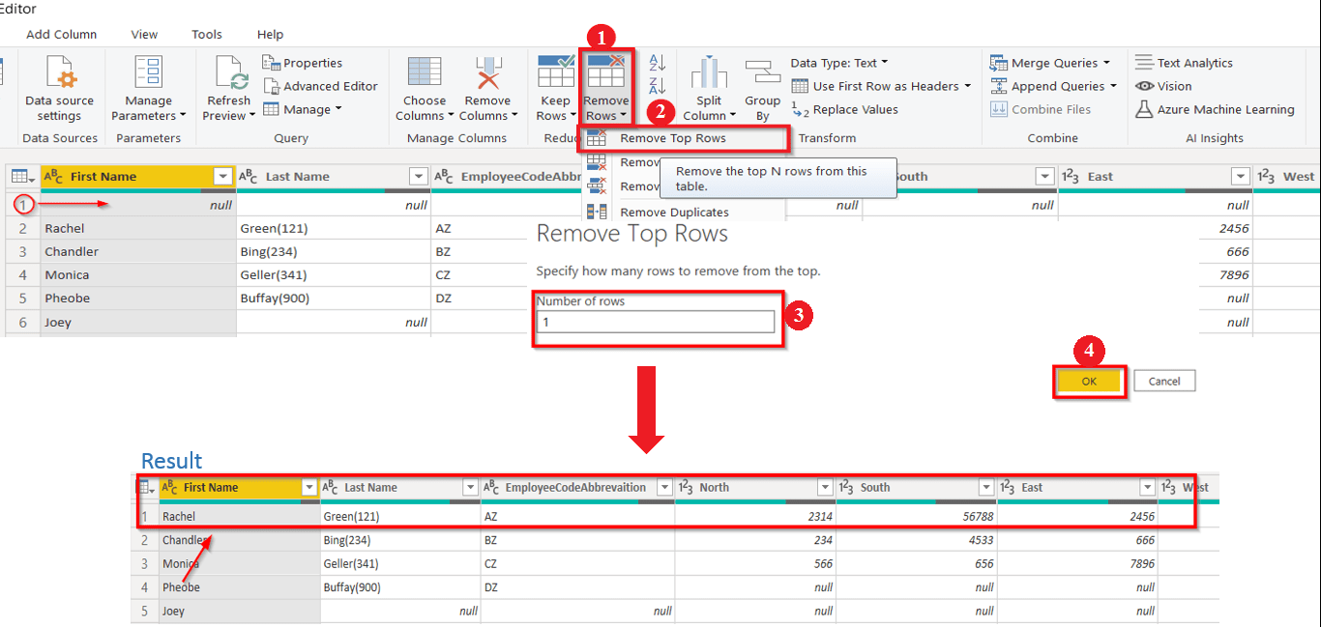

**Fig:4.3.3 Transformed Data**

### Replace Null Value

Let’s try replacing a value, say we want to replace all the null values in our data with ‘0’.

1. Select all the columns you want to replace the value, “**Right-Click,”** on any row containing the null value. Select “**Replace Values.”**
2. It asks you to specify the value you want to replace.
3. Then next, set the value you want to replace with.
4. Click on**“OK.”**

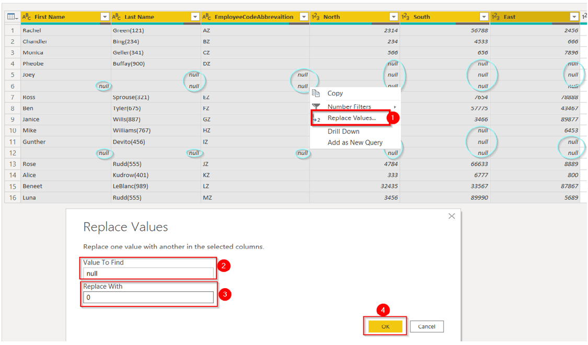

**Fig 4.3.4 Replace null Values**

##### Here you see the result; all the null values have been replaced by 0.

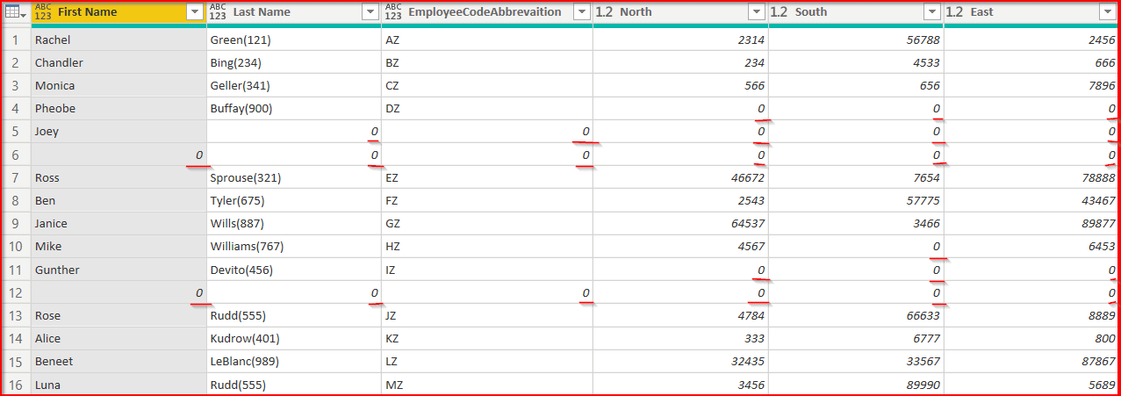

**Fig 4.3.5 Query Management with zeros in Table**

### Remove Unnecessary Rows

We want to remove all the unnecessary rows to make our data more readable in the next step. Let’s say we want to remove rows that contain 0 in their data.

1. Select the first column, drop down the list by “**Left-Click**.”
2. **Deselect** all the items you don’t want in your datasheet.
3. Click on**“OK.”**

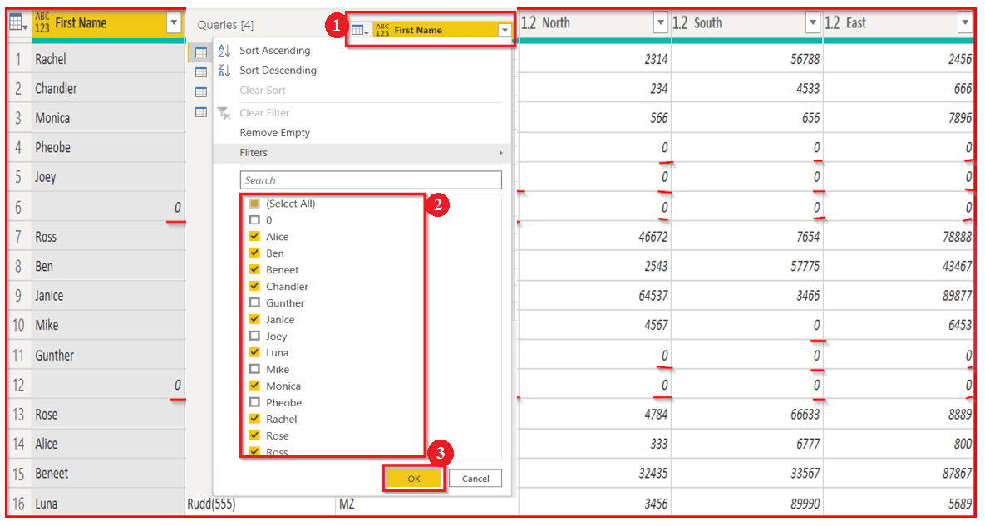

**Fig 4.2.6 Removing Values**

##### The sorted sheet after removing all the unnecessary rows will look like this.

### Rename Column Headings

The most straightforward task in Power BI is to Rename the column heading.

**“Double Click”** on the column heading will get highlighted with a blue mark, then replace the name with a new header.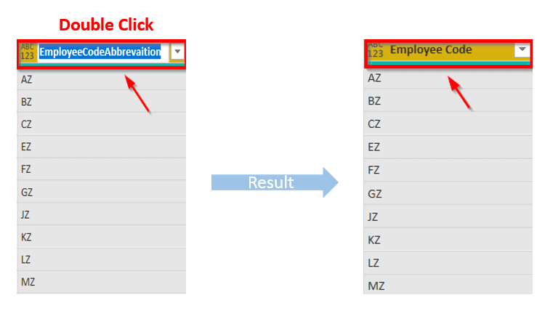

**Fig 4.2.7 Before and After Transformation**

### Separating into two Columns

Now what we want is to split the name and employee id into their column.

1. Select the column “**Right-Click**” on the column heading.
2. A drop-down list will appear; select **“Split Column**.”
3. Then we go for “**By Delimiter**” to split the column.

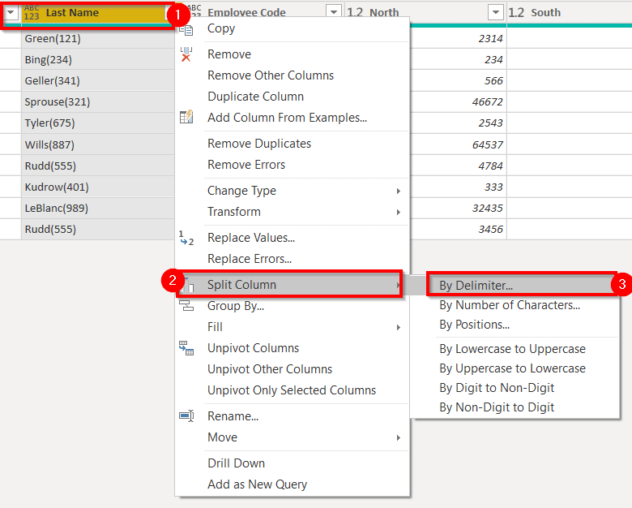

**Fig 4.3.8 Query Column Management**

4. The ‘Split Column by Delimiter ‘page appears; we want to separate the column from the open parenthesis; thus, we customize the option and fill **“(“**in the box.”

5. Click on “**OK.”**

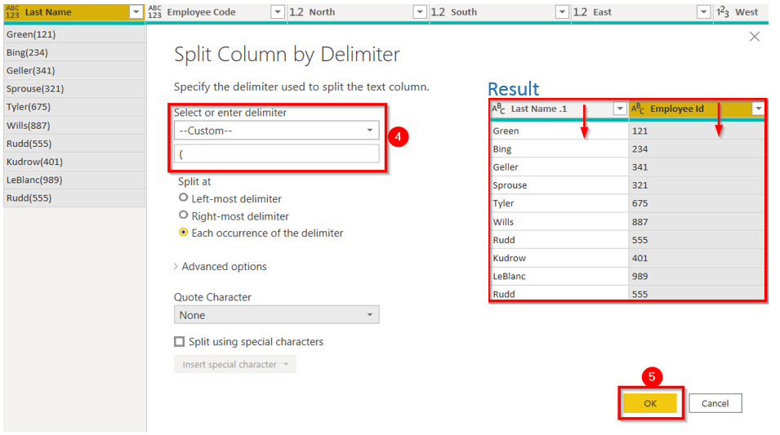

**4.3.9 Query Management with Filtering**

### Merge Columns

I can almost hear you thinking about what we need to merge two columns, so here you go.

1. Select the two columns you want to merge.
2. Go to “**Add Column.”**
3. Select the “**Merge Columns”** option.
4. Merge Columns page will appear; specify the separator.
5. Click on “**OK.”**

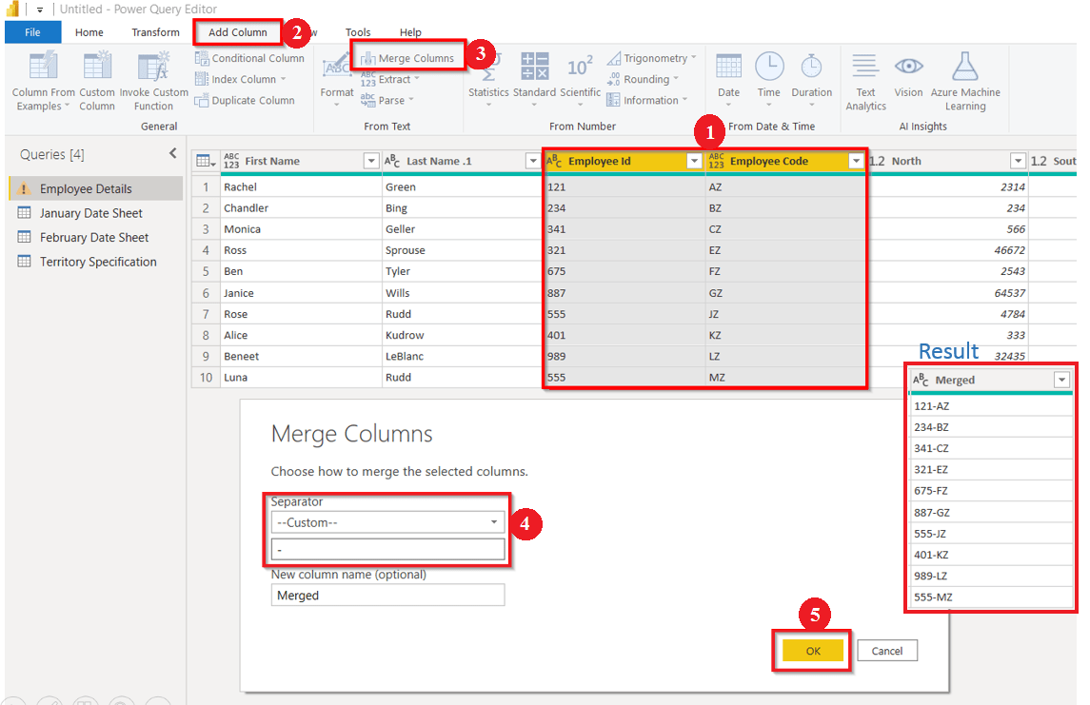

**Fig 4.3.10 Merge Queries**

### Unpivot the Columns

Unpivot column means to unpack the similar values and group them under a single heading. When we look at our unsorted data, we see that all the four columns North, South, East, and West, show the same metric. Therefore, we want to separate it into two columns where one column will show Region and the other Sale.

Select all four columns, Right**-click** on any heading, and then select “**Unpivot Columns.”**

It will result in it two new columns, name Attribute, and Value. Change the column name.

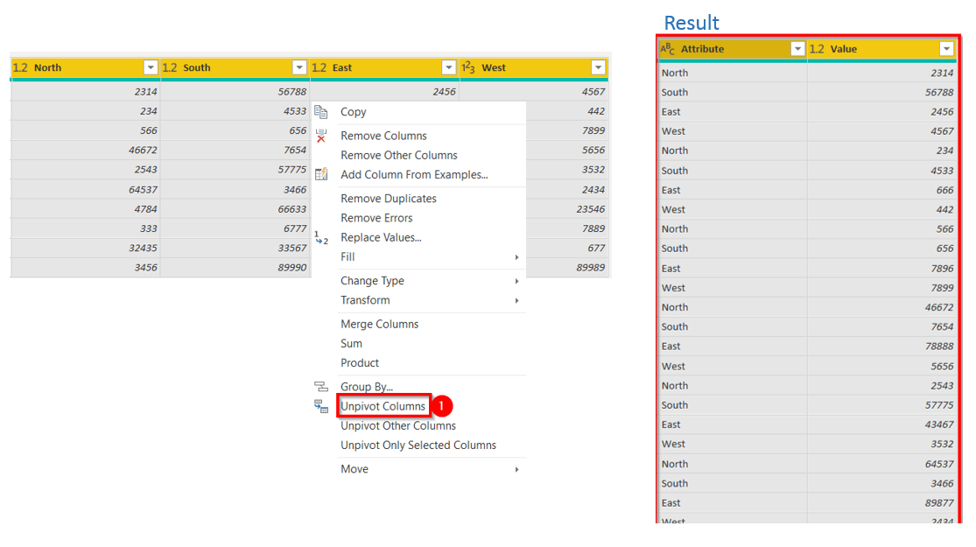

**Fig 4.3.11 Query Unpivot**

##### 4.4 MODEL PLANNING AND MODEL BUILDING

**Building a data model:**

David moves to the next level in Microsoft Power BI usage. We are probably cheating a bit now, but we wanted this book to show you what Power BI can do for you when you master it, not just demonstrate its basic features. To do that, we presume that David—encouraged by the good results so far—spent some time learning the basics of data modelling and the DAX language. Having learned more details about Power BI, he begins again building 231 C H A P T E R 6 | Building a data model the budgeting solution, but this time he can trust his better knowledge of the tools.

**Loading individual tables:**

Recall from Chapter 3 that David needed to speak with Karin to gain access to the Microsoft SQL Server database containing a view that returns sales for the past three years. David learned that he can perform an analysis on sales in a better way if—instead of using Karin’s view—he loads the data from the original tables were Karin stores Contoso information. So, he arranges a meeting with Karin to gather more information about the internal structure of the Contoso data warehouse. Karin explains to him that the database is organized in tables that he can access by using individual views (one per table). There is a table for each business entity of Contoso’s business:

• Products This table contains information about the products sold by Contoso.

Building a data model

• Sales This one contains detailed sales, one row for each individual sale.

• Stores This table has information about the stores where the sales were transacted.

• Date This is a helper table that contains the calendar.

David learned in a Business Intelligence class that such a table is of paramount importance when building a good data model. Karin gives David access to the views so that he can load the granular information. David decides to begin again from scratch, so he opens Power BI Desktop and loads these tables into a new model, following the same procedure he did to load the Sales2015 view. The only difference is this time he loads four tables at once

**Implementing measures:**

The model, as it is, still requires some adjustments. First, David hides all of the columns that should not be visible when creating reports. He does this by going to Report View, selecting the table columns, right-clicking one, and then clicking Hide. David hides all of the keys and the columns that would be misleading if they were summed straight.

**Creating calculated columns:**

Having more power typically raises the requirements of the data model. As an example, consider the line chart: having the sales of the three years with different lines might be useful for a comparison of different years; however, if you want to analyse the behaviour of sales over the three years, it would be much better to show a single line that spans all of the years. The problem is that the Date table contains the month name, and you can easily use it as we did in Figure 6-4, but if you remove the year from the legend, you get sales divided by month, not by month and year

**Improving the report by using measures:**

When you use calculated columns and measures to perform analyses, you’re limited only by your imagination. For example, with a few calculations you can easily build a report like the one shown 243 C H A P T E R 6 | Building a data model in Figure 6-8, which shows a bubble chart with the number of products versus the margin divided by category, where the size of each bubble is the amount sold.

**Integrating budget information:**

So far, David is excited about the power of his analytical tool; so much so, in fact, that he’s forgotten that the task is about budgeting, not sales analysis. This is one of the major drawbacks of using Power BI: it is so much fun to dive into data and analyse it that you might become lost in evocative reports. Now it’s time to get back to business and integrate the budget information. Loading the budget information from Excel is straightforward, and David has already used the 245 C H A P T E R 6 | Building a data model technique. But a problem arises as soon as he looks at the data model. The new table containing the budget does not have any relationship with the other tables

**MODEL PLANNING:**

Model planning is phase 3 of lifecycle phases of data analytics, where team determines methods, techniques, and workflow it intends to follow for subsequent model building phase.

During this phase that team refers to hypothesis developed during discovery, where they first became acquainted with data and understanding business problems or domain area.

**Types of Schemas:**

Following are 3 chief types of multidimensional schemas each having its unique advantages.

* Star Schema
* Snowflake Schema
* Galaxy Schema

**Star Schema:**

**Star Schema** in data warehouse, in which the centre of the star can have one fact table and a number of associated dimension tables. It is known as star schema as its structure resembles a star. The Star Schema data model is the simplest type of Data Warehouse schema. It is also known as Star Join Schema and is optimized for querying large data sets.

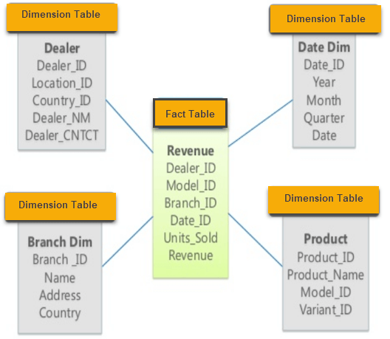

**Fig 4.4.1 Star Schema**

**CHAPTER 5**

#### SYSTEM DESIGN IMPLEMENTATION

##### 5.1 Sales Analysis Implementation

## Importance and benefits of sales analysis

Do you know which products of your company are faring the best and the worst? Sales data analytics examines sales reports to evaluate how your company is performing against its goals. Here’s why you need to integrate it into your [sales operations](https://blog.close.com/sales-operations).

* **Make data-driven decisions instead of relying on gut instinct**- Effective and regular sales analysis unveils how your [sales plan](https://blog.close.com/create-sales-plan) is panning out and measures the performance of every individual rep on your team in real-time.
* **Find your most profitable customers -** Your sales reps should spend the majority of their time engaging with high-quality leads that add value to your company. So it’s invaluable to identify the [characteristics of customers](https://blog.close.com/ideal-customer-profile) that spend the most money on your products and remain loyal to your company.
* **Get awareness on the market trends** - Are you preparing to launch a new product? Are you planning your future course of actions in terms of stocking inventory, rolling out schemes, and modifying your manufacturing process (if applicable)? A sales analysis report identifies market opportunities and trends to support these efforts.
* [**Serve your customers better**](https://blog.close.com/saas-service)**-**If you can nail down why a deal closed, you can keep your customers happy and forge deeper relationships. Once you understand their needs better and your brand develops goodwill, you can also upsell and cross-sell to these existing customers.
* **Expand your market reach -**Sales data analysis and interpretation will also fetch intel on your non-customers. The information is invaluable for sharpening your [sales pitches](https://blog.close.com/create-perfect-sales-pitch) and personalizing your future marketing activities to potentially find new customers.

##### 

**STEPS OF SALES DATA ANALYSIS:**

* 1. **Data collection from Data Sources:**

**MySQL:**

To add, access, and process data stored in a computer database, you need a database management system such as MySQL Server.

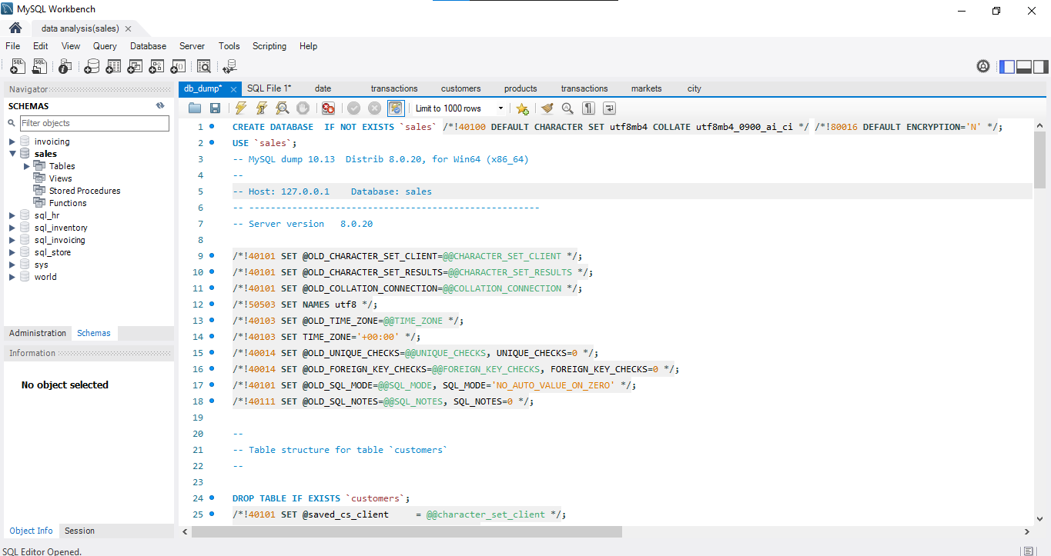

**Power BI Data Collection from MySQL:**





**Fig 4.4.3 Power BI Data Collection from MySQL:**

* 1. **Data Transformation:**

## Power BI Desktop

Power BI Desktop is an application that helps connect, extract, transform, load, model, and visualize data. Power BI Desktop also assists in building report and model data.

## Power Query Editor

It is the built-in Business Intelligence instrument present in Power BI Desktop to clean and transform your data. Any changes in the data are made with the help of Power Query Editor. All of the functions we will perform in this blog are done on Power query Editor. To get Power Query Editor, select Home > Transform data in Power BI Desktop.

* 1. **Import Data**

• Go to the “**Home”** tab in the ribbon section.

• Click on “**Get Data**,” it will provide you with the options to source the data from a different platform.

• As we have our unsorted data in Excel, Select **“Excel**.”



* 1. **ETL (Extract Transform Load):**

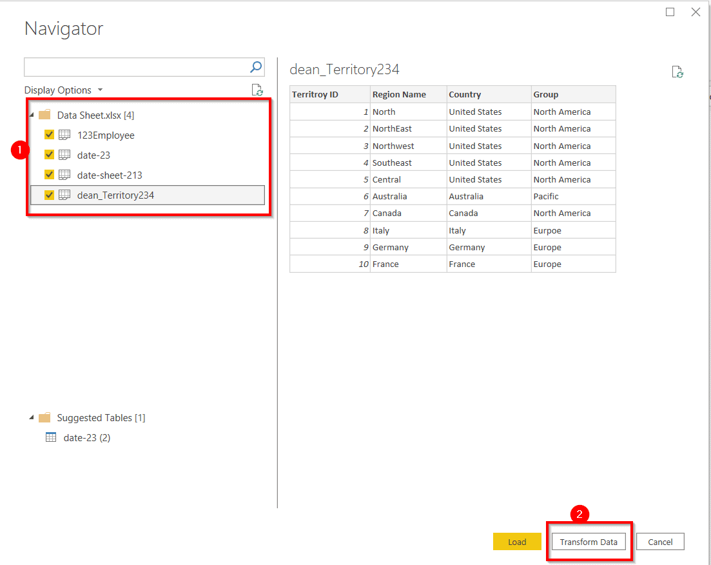

**Fig Dataset Loading from ETL process:**

* 1. **Model Building:**
* Loading Individual Tables
* Implementing Measures
* Creating calculated columns
* Improving the reports by using measures
* Integrating Budget information
* Reallocating the budget
  1. **Data Visualization:**

The type of data visualization technique you leverage will vary based on the type data you’re working with, in addition to the [story you’re telling with your data](https://online.hbs.edu/blog/post/data-storytelling).

Here are some important data visualization techniques to know:

* Pie Chart
* Bar Chart
* Histogram
* Gantt Chart
* Heat Map
* Box and Whisker Plot
* Waterfall Chart
* Area Chart
* Scatter Plot
* Pictogram Chart
* Timeline
* Highlight Table
* Bullet Graph
* Choropleth Map
* Word Cloud
* Network Diagram
* Correlation Matrices

1. **Pie Chart:**

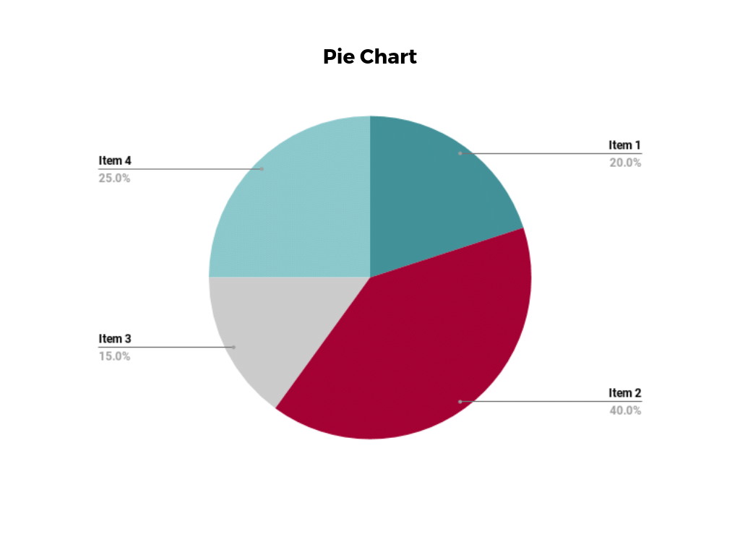

1. **Bar chart:**

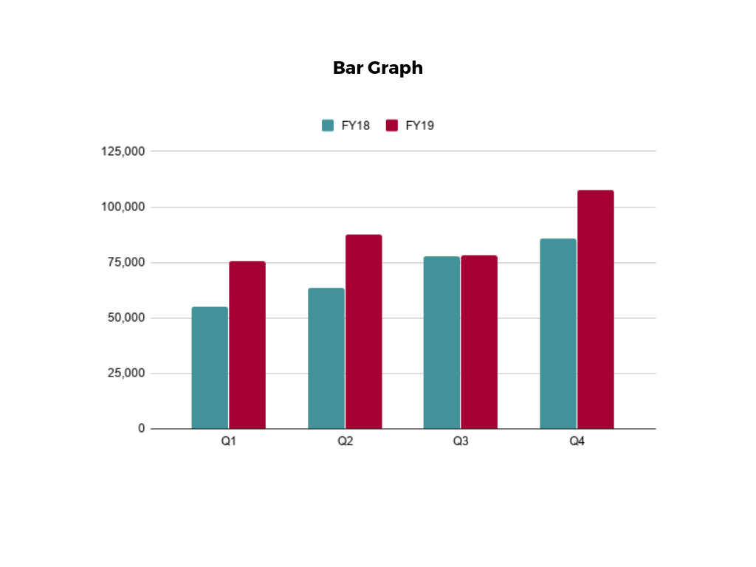

1. **Histogram:**

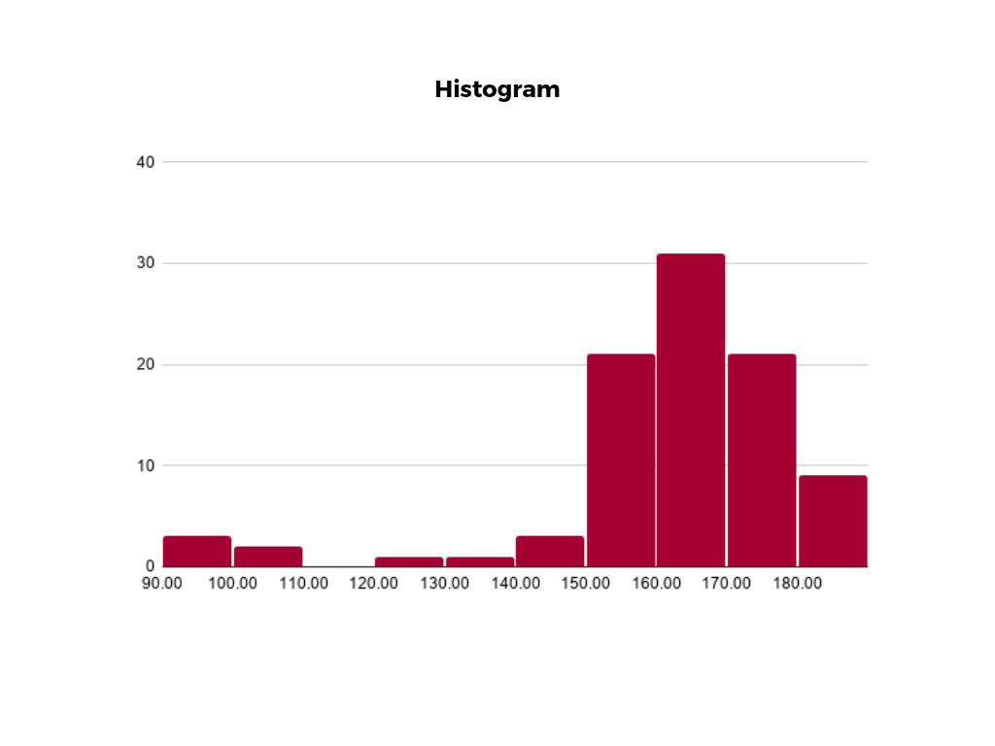

#### CHAPTER 6

#### RESULTS AND DISCUSSIONS

##### 6.1 Reports creation of sales Data

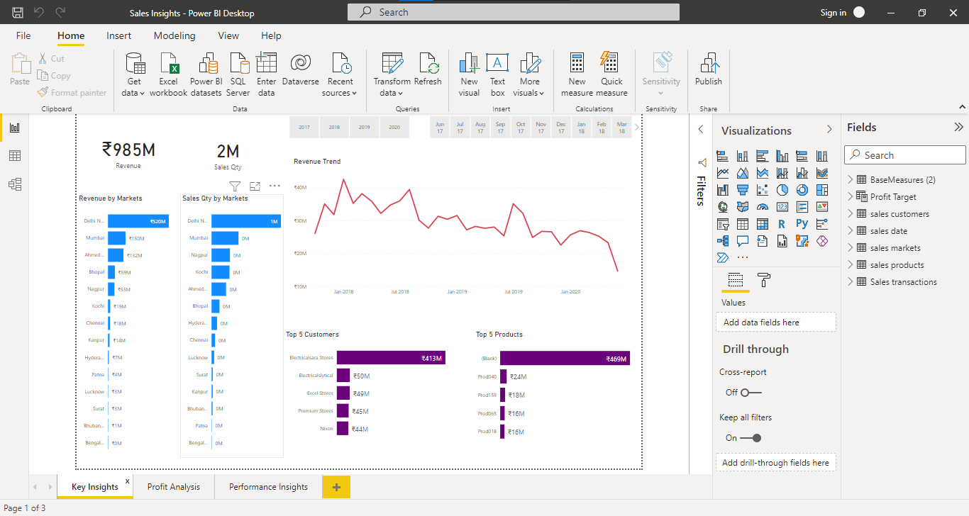

**Fig: Sales Key Insights**

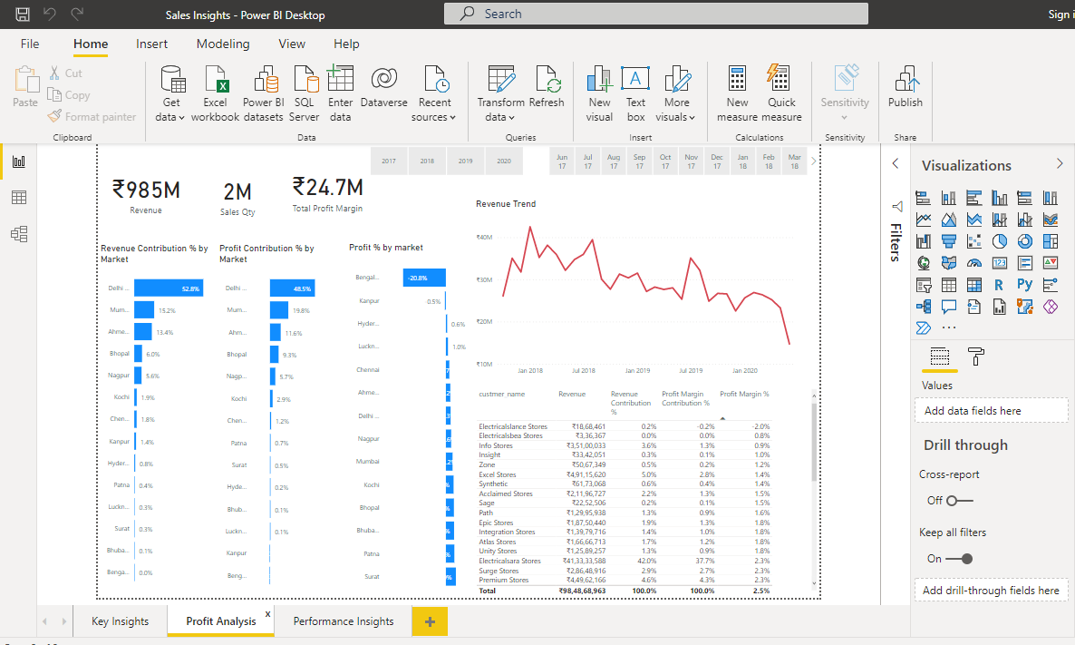

**Fig: sales Profit Analysis**

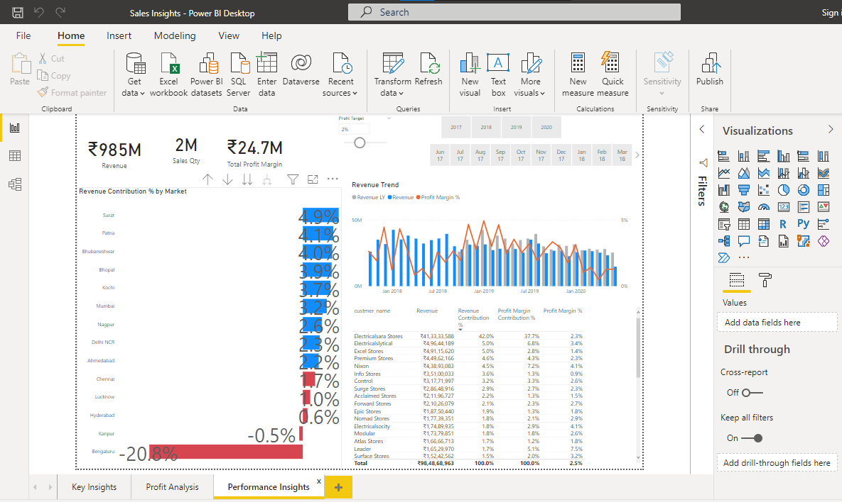

**Fig: Sales Report on performance Analysis**

###### 6.2: DECISION MAKING

B2B organizations should be highly involved in their sales decision-making process. And to do that, they must learn how to leverage sales data properly. But, why do sales data even matter?

Let us help you out here:

### 1. Discover your ideal customers

Your ideal customer is any individual who intends to buy your products and services. But the question is how do you discover the individuals who have sufficient purchase intent and are willing to purchase from you? That’s where the concept of sales data comes into the picture.

### 2. Expedite your prospecting process

One of the major activities of any sales rep is reaching out to more [prospects](https://www.salesken.ai/blog/sales-prospecting-guide) through cold calls, social selling, and emails. But it will be a complete waste of time for them if they don’t have proper sales data.

### 3. Ensure sales process optimization

Sales managers are always seeking new ways to improve their sales team’s performance. But how are they supposed to do that if they don’t have actionable insights?

**Ways to achieve the sales data Growth:**

### Identify new lead generation options

High-quality sales data can be a major source of new lead generation for your sales team. Once you have successfully collected the sales data from authentic sources, you can use a sales analytics tool like [**Salesmen**](https://salesken.ai/product) to discover the purchase intent of the prospects. Such a tool can help you with lead scoring. That way, reps will understand which prospect is most likely to convert into customers and can direct their efforts accordingly.

### Don’t chase prospects with low purchase intent

Not all customers will fit the criteria of your buyer persona. In [B2B selling](https://www.salesken.ai/blog/b2b-customer-journey-steps), reps should always focus on converting leads who are a good fit. B2B lead generation process involves high costs, energy, and a lot of valuable time. You can’t risk your conversion process by targeting bad-fit prospects as it will delay your whole lead generation process.

### Nurture and build relationships with leads and customers

High-quality sales data not only help you identify the proper leads but also helps you nurture them with suitable strategies and approaches.

### Experiment and improve your communication process

Trial and error is the secret to a successful sales or marketing campaign, so what’s better than a regular trial and error process? A data-driven one. So, use the collected sales data to experiment and apply the results to modify your marketing strategy.

Try different ways of communication with your prospects. From email outreach to social media outreach, try it all. Also, don’t stop at the experiments. Analyse the results and build your sales strategy accordingly.

### 5. Track your sales team’s performance regularly

Use a sales enablement tool like Salesmen to track your sales team’s performance regularly. Here’s how it can help:

* With cutting-edge [conversational analytics](https://www.salesken.ai/blog/conversational-intelligence-accelerate-sales-journey), SalesKen can analyse your reps’ conversations with prospects.
* It can help offer in-depth insights on the prospect’s purchase intent and highlight improvement areas in the sales pitch.
* SalesKen can further provide sales coaching to the reps. That way they can work on their individual strengths and weaknesses and perfect their sales pitches.

### 6. Master the decision-making process

Use consistent sales data to support your sales decision-making process. Updated sales datasets can predict future sales patterns for your team and drive more lead generation opportunities.

6.3 LIMITATIONS

The main disadvantages of sales forecasting include the following: Time-Intensive Completion While there are various methods of sales forecasting, the two broad approaches include manual and data-driven processes. In either case, significant time is required to develop forecasts.

6.4 FUTURE SCOPE

The main disadvantages of sales forecasting include the following:

* **Time-Intensive Completion**
* **Expensive Technology Tools**
* **Internal Bias**

**CHAPTER 7**

#### SCREENSHOTS

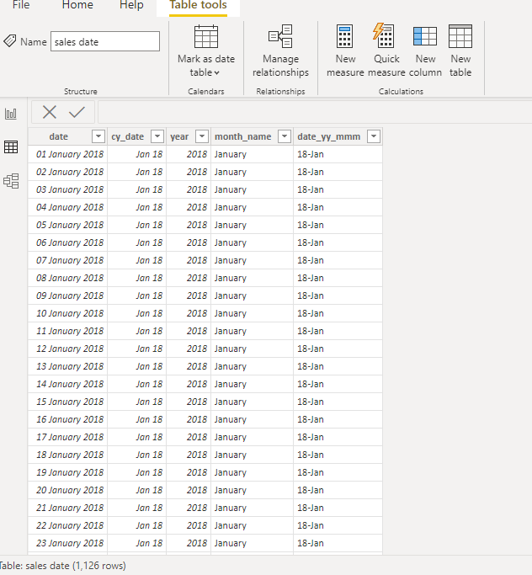

**Fig: Sales Dataset example query**

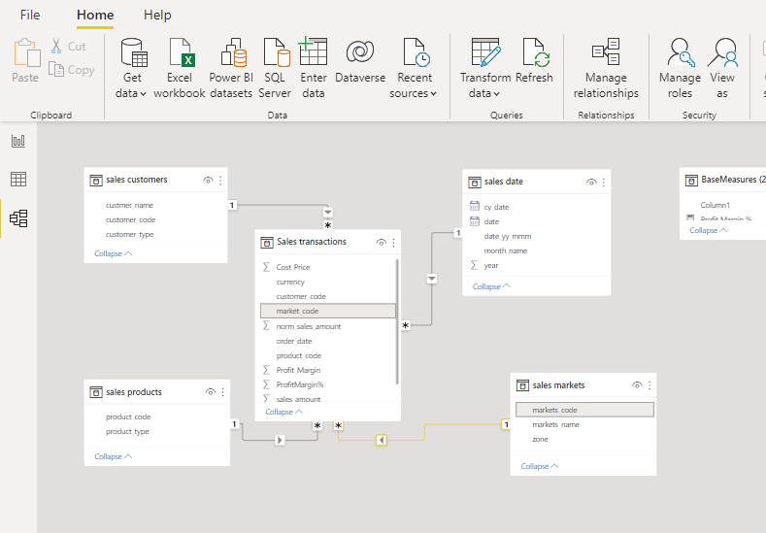

**Fig: Relation Building**

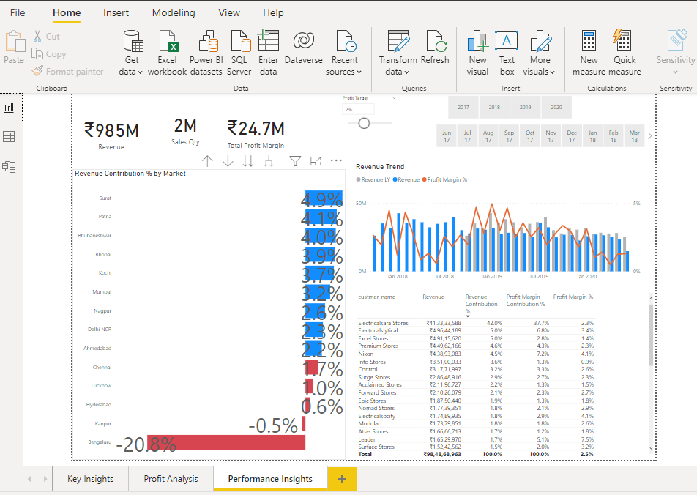

**Fig: Key Performance Insights**

#### CHAPTER 8

#### CONCLUSION AND FUTURE WORK

##### 8.1 Conclusion

Now that you know the importance of sales analysis for your business, it’s time to implement it. A sales analysis tool shows both sides of the coin: On the one hand, you **get to know the best performing sales agents, segment hot leads, and identify the campaigns that bring in big numbers of customers.** n the other hand, you can weed out cold leads, train agents who are struggling, and tweak or improve failed products or campaigns. here are a few [great CRM software](https://www.engagebay.com/blog/operational-crm/) in the market today. For small businesses that need a comprehensive yet affordable sales analysis software, [Engage Bay](https://www.engagebay.com/) is an excellent choice. It’s more than a sales analysis tool, though. You get hundreds of marketing, sales, and customer service features — all packed into affordable plans. **You get all your reports in neatly organized dashboards.** Oh, and you can create custom ones, too.

##### 8.2 Future Works

Sales forecasting allows you to not only project how much revenue your team will close but also proactively influence current and future deals – by getting ahead of potential blockers, course correcting when you’re trending off target, moving into emerging markets, and more.

But forecasting isn’t as easy as asking your sales reps to give you a number. An accurate, actionable sales forecast requires a lot of work, cooperation from all parts of your sales team and visibility into your sales pipeline.

**CHAPTER10**

#### REFERENCES

https://www.slideshare.net/RubenRodriguez55/sales-analysis-reference

<https://www.point-of-reference.com/blog/the-sales-reference-kpi/>

<https://www.engagebay.com/blog/sales-analysis/>

**-**MATT DIXON, co-author of *The Challenger Sale* and *The Challenger Customer*, senior partner, Korn Ferry Hay Group   
 -DANIELLE HERZBERG, head of SMB Sales, Slack

<https://www.amazon.com/Sales-Magnet-Customers-Without-Calling-ebook/dp/B00B4XHQIQ/ref=pd_sbs_sccl_1_3/141-7637843-6591154?pd_rd_w=Xl0Av&pf_rd_p=3676f086-9496-4fd7-8490-77cf7f43f846&pf_rd_r=VWCJ8VDRETA6KN35Z12Z&pd_rd_r=b05ef126-8346-4783-8b96-ddaee76baab6&pd_rd_wg=uSxfY&pd_rd_i=B00B4XHQIQ&psc=1>

<https://www.amazon.com/Inbound-Selling-Change-Match-People-ebook/dp/B07C85BMBF>

<https://www.amazon.com/New-Sales-Simplified-Prospecting-Development-ebook/dp/B0094J7S9Y/ref=pd_sbs_sccl_1_2/141-7637843-6591154?pd_rd_w=Xl0Av&pf_rd_p=3676f086-9496-4fd7-8490-77cf7f43f846&pf_rd_r=VWCJ8VDRETA6KN35Z12Z&pd_rd_r=b05ef126-8346-4783-8b96-ddaee76baab6&pd_rd_wg=uSxfY&pd_rd_i=B0094J7S9Y&psc=1>

<https://www.amazon.com/New-Sales-Simplified-Prospecting-Development/dp/0814431771/ref=zg_bs_2712_43?_encoding=UTF8&psc=1&refRID=RX0NWWSMEN14V08EWART>

<https://www.amazon.com/Fanatical-Prospecting-Conversations-Leveraging-Telephone/dp/1119144752/ref=pd_sbs_sccl_2_2/141-7637843-6591154?pd_rd_w=Fou7K&pf_rd_p=3676f086-9496-4fd7-8490-77cf7f43f846&pf_rd_r=C89RFKH4GXZ0RAPPMZR1&pd_rd_r=045ee40b-bde4-4aa9-ae70-eb634d2437cd&pd_rd_wg=DS862&pd_rd_i=1119144752&psc=1>

<https://www.amazon.com/Challenger-Sale-Control-Customer-Conversation/dp/1591844355/ref=pd_sbs_sccl_2_4/141-7637843-6591154?pd_rd_w=Fou7K&pf_rd_p=3676f086-9496-4fd7-8490-77cf7f43f846&pf_rd_r=C89RFKH4GXZ0RAPPMZR1&pd_rd_r=045ee40b-bde4-4aa9-ae70-eb634d2437cd&pd_rd_wg=DS862&pd_rd_i=1591844355&psc=1>